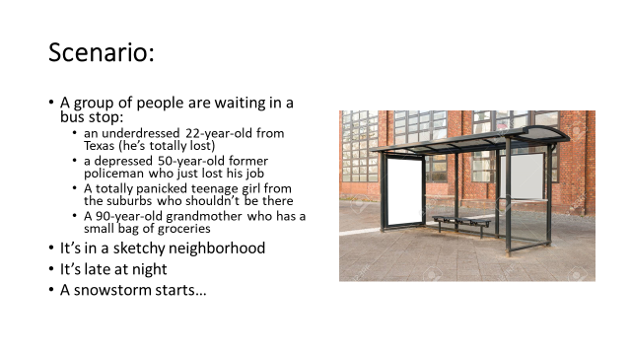
***Directions
- Start a story with the above information (pick one of the characters and write with him/her as narrator)
- Stop at 1 page
- Re-start the same story with a different character as narrator
- Stop at 1 page

