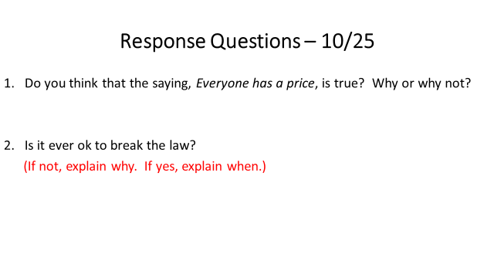
***1/2 page minimum for each question
***Give specific examples to support your opinion

