French and Indian War

Who fought?
- French and Native Americans vs. British (with support from the colonists)

When did the war take place?
- Started in 1756
- Ended in 1763

Where was it fought?
- Ohio Valley *region between the Ohio River (in the east) and the Mississippi River (in the west)

Causes?
- Both France and England were in a race to expand their empires (by establishing colonies)
- Colonies were a source of power and revenue ($) *** #1 source of $ = beaver pelts
- The Ohio Valley was an area between French and English territories, and it was rich with valuable resources

How did it start?
- French built a fort (Fort Duquesne) at the site of modern-day Pittsburgh
- Word of the fort got to the governor of Virginia
- Militia from Virginia was sent to tell the French they were trespassing and kick them out (this group was led by 22-year-old George Washington)
- When they were near the fort, Washington and his troops ran into a French scouting party, fired at them, and took them hostage
- Washington and his troops came under attack, so they built a fort (Fort Necessity) as protection
- They were hugely outnumbered and surrendered
- The French released Washington and his men and sent them back to Virginia (where they were hailed as heroes for attacking Britain’s sworn enemy)
Why were the British losing the war when they had such an advantage in numbers?
*** 90,000 French colonists and 18,000 soldiers vs. 1.5 million English colonists and 42,000 soldiers
- French were better organized
- French had more-experienced fighters
- French had Native American allies (they saw the French as the lesser of two evils)
- French were willing to depart from “traditional” war tactics

What “turned the tide” for the British?
- New commander (William Pitt)
- Sheer numbers of troops (more and more soldiers were brought from England to fight)
- Naval superiority (especially in the Great Lakes)
- Willingness to play dirty ***Germ warfare: one general, while negotiating with attacking Native Americans, gave them blankets. These blankets had been taken from a “Smallpox hospital”, and the disease quickly spread through and ravaged the Native American population

How did the war end?
- Treaty of Paris (1763)
- France gave up all of Canada, all land east of the Mississippi Valley, Florida, and a bunch of Caribbean islands

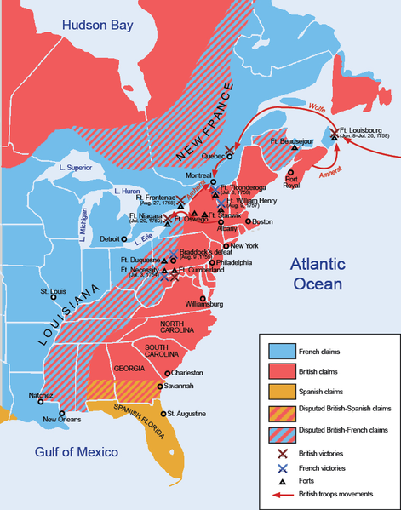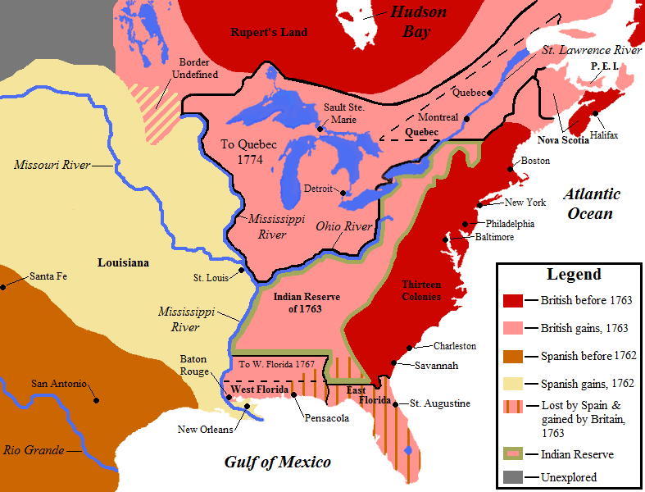
Before After

