Resources for “The Second Great Awakening”

Picture #1
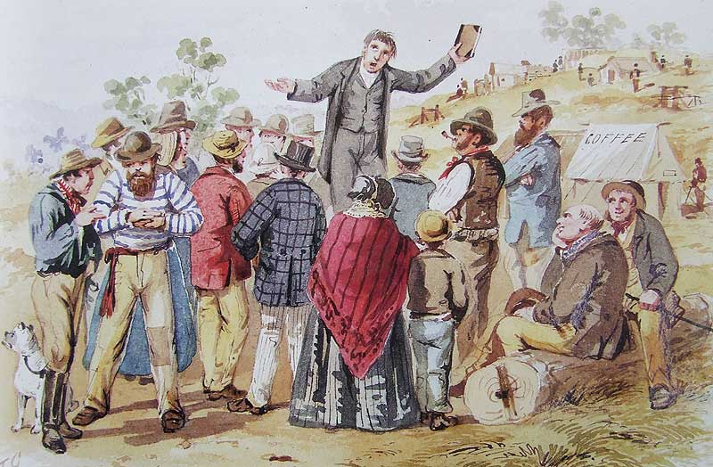

Picture #2
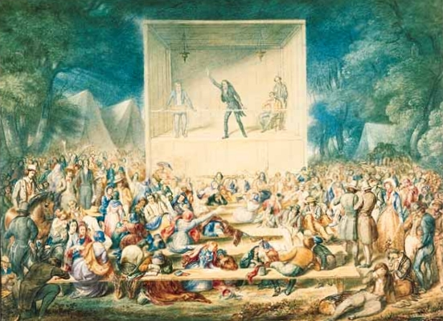

Picture #3
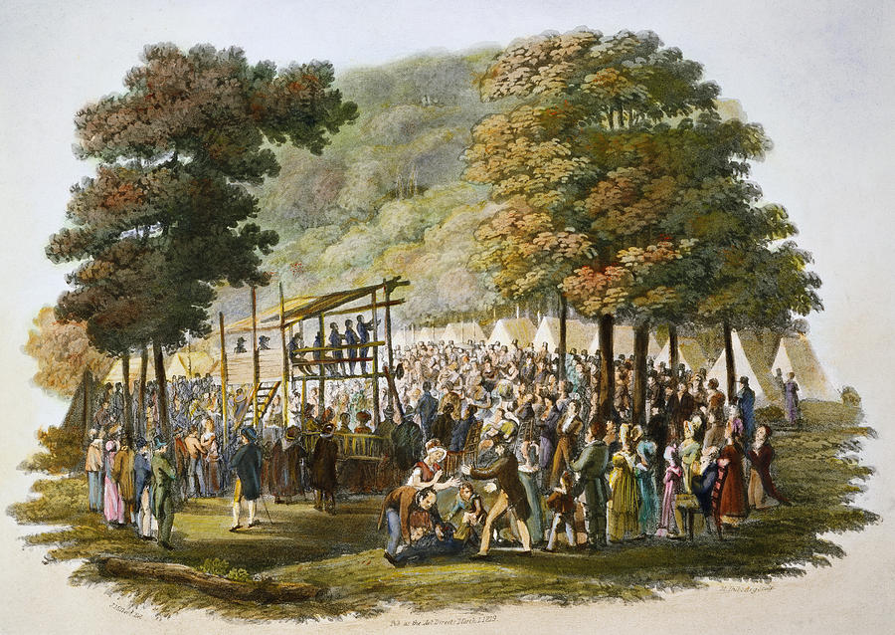

Video clip:
(click on the following link, and watch the short movie clip)
https://youtu.be/fDx628jn1YI

