Resources for NBE #2 – Second Great Awakening

Picture #1
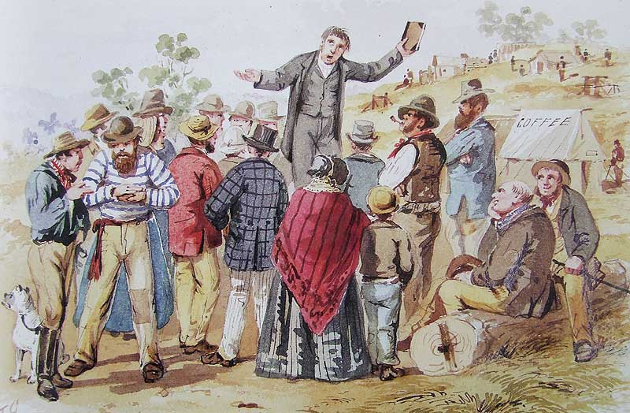

Picture #2
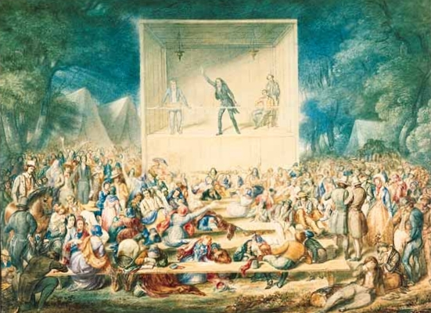

Picture #3
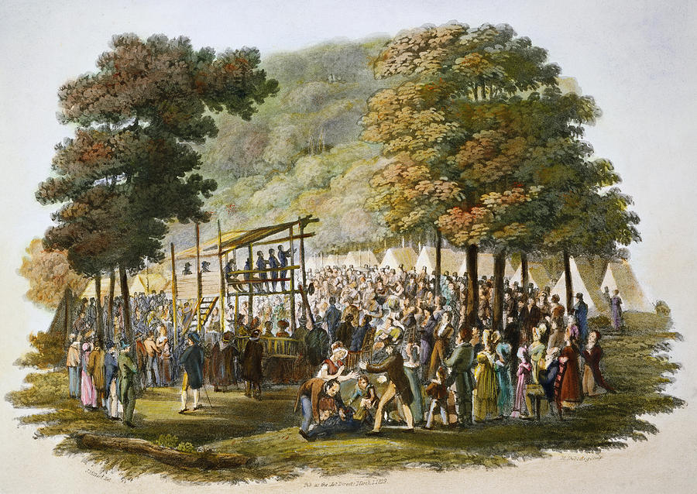

Video clip:
(click on the following link, and watch the short movie clip)
https://youtu.be/jPqaz9QfK5I

