Name:

Review of Ch. 11-12
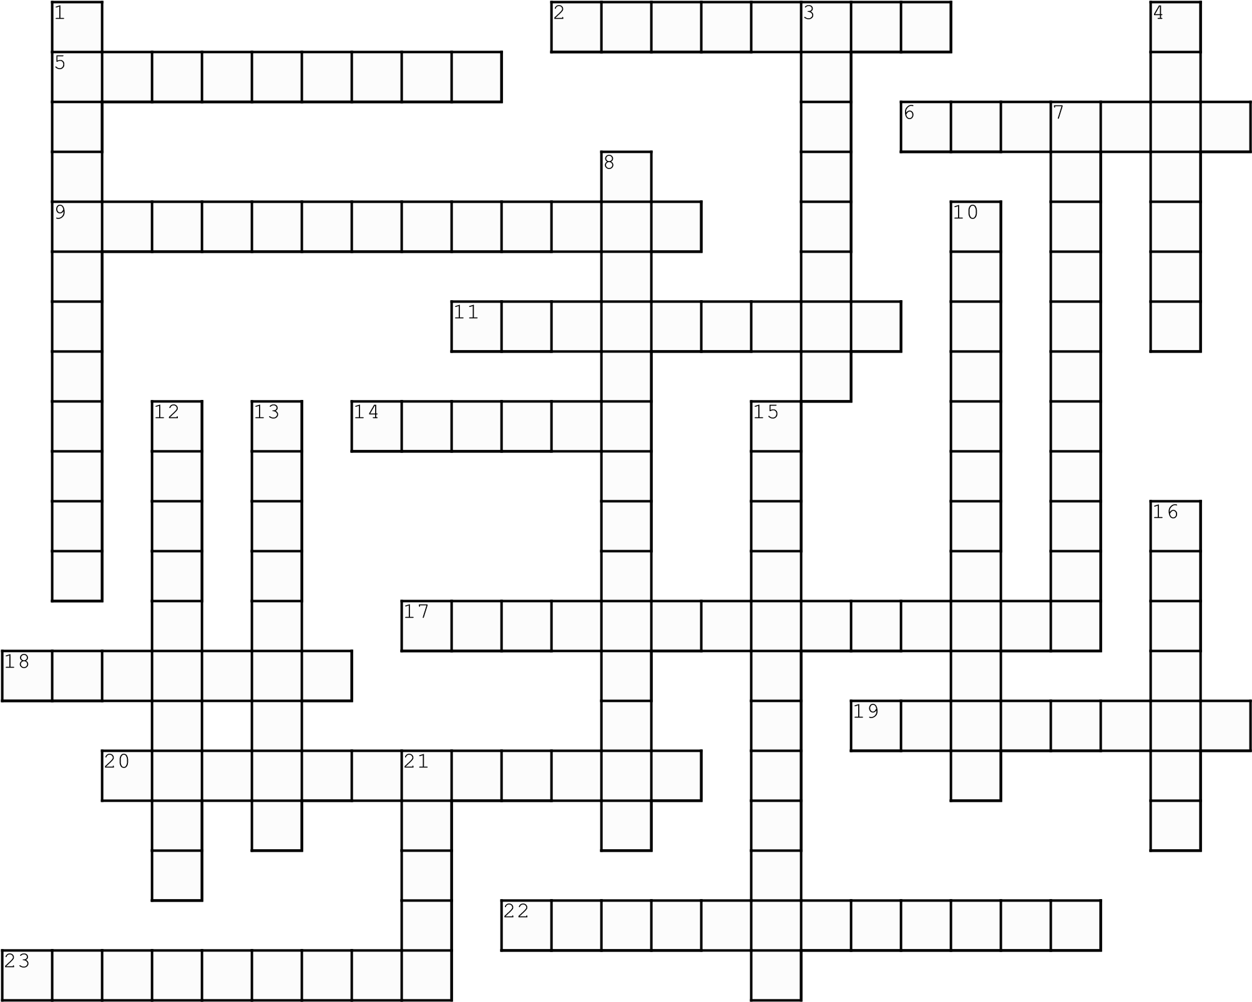
Created with TheTeachersCorner.net Crossword Puzzle Generator

Across
2. Native american leader who tried to keep
American settlers from spreading west 5. President Washington warned against making permanent ___
6. 4th president; president during War of 1812
9. General who won the Battle of New Orleans
11. Washington's secretary of war
14. Countries targeted by the Monroe Doctrine
- Rights violated by the Alien and Sedition Acts
- to ignore a law
- Alexander Hamilton was Washington's secretary of the ___
- Hamilton wanted this to make our economy strong
22. Washington urged Americans to practice
neutrality and ___
23. Polar opposite to Hamilton

Down
1. Pirates from here kidnapped sailors and sold them into slavery
3. to encourage others to rebel against the gov't 4. Western farmers hated the tax on whiskey because it took away their ___
- Sailors are kidnapped and forced to work for another navy
- warned foreign countries to stay out of the
Americas
10. Visitor from France who took things too far when he threatened Washington's life 12. Most lopsided military victory in US history 13. French secret agents demanded protection money
- states could ignore laws they believed to be unconstitutional
- Stop doing business (trade) with another country
21. living here; from another country; not a citizen

