George Washington said (about U.S. foreign policy):
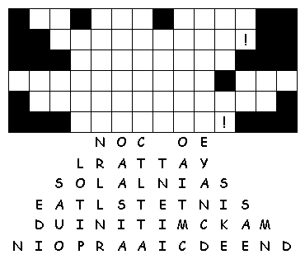

Alexander Hamilton said (about our nations’s finances)
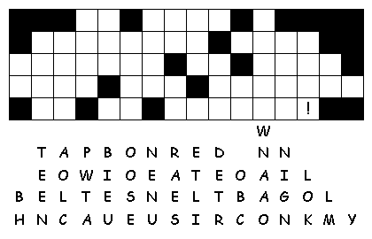

To Protect the new Latin American countries…
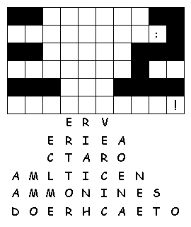

Against President Adams…
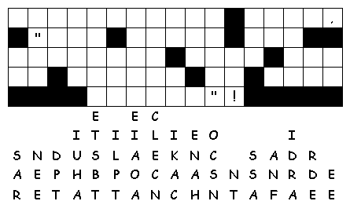

Whiskey Rebellion (the farmers said…)
