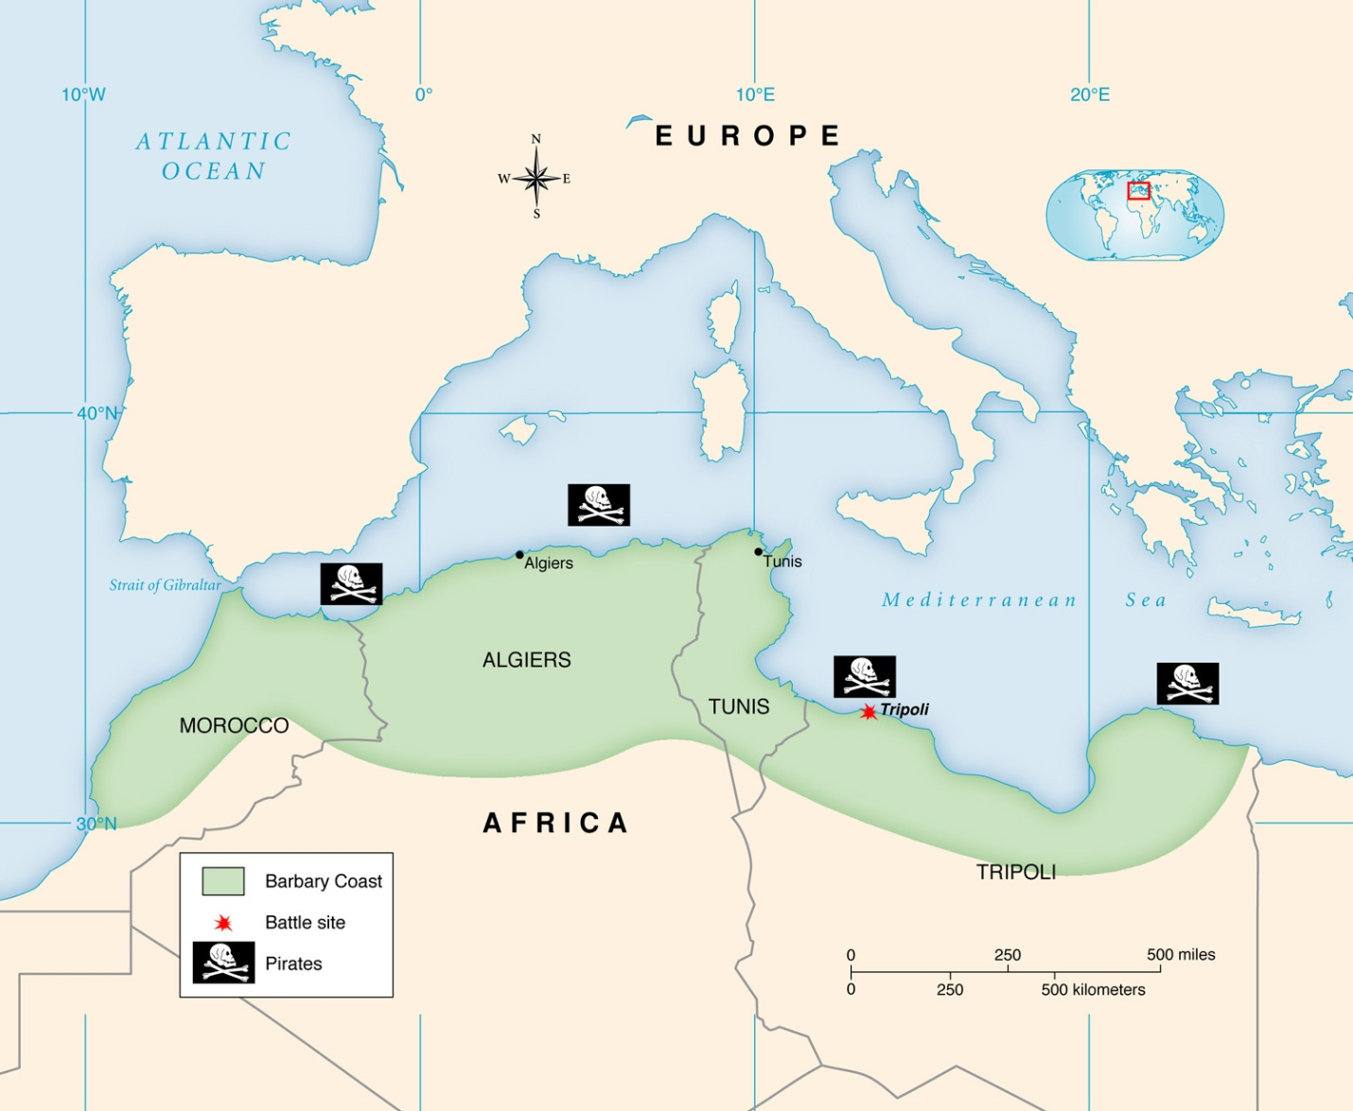
Image for “Dealing With Pirates” (Jefferson)

