Station #1
Your job at this station is to do two things:
- Review/revise your answers to Question 2 (parts a, b, c)
- Make sure your map of the Battle of Yorktown looks exactly like Mr. B’s (same colors and labels)

Station #2
Your job at this station is to discuss/revise NBE #17 – Vocab Ch. 8
- Take turns reading each of the definitions out load to the group
- Adjust your answers to make sure they match-up with Mr. B’s

Station #3
Your job at this station is to make sure (1) your graphic organizer (NBE #18) has ALL of the highlighted information, and that (2) each point is highlighted on your paper

Station #4
Your job at this station is to make sure your first summary (NBE #19) contains the following information ***If it doesn’t, please add any missing information to the column next to your summary
- Land Ordinance of 1785
- 2 Purposes: (1) organize new territory, and (2) raise $ for our new country
- Western Lands divided into 6-mile squares
- Each 6-mile square called a “township”
- Each township divided into 36 equal sections (1 square mile each)
- 1 square mile = 640 acres
- Section #16 reserved for public schools
- Other sections could be subdivided and sold to settlers and land speculators (real-estate investors)

One “Township”
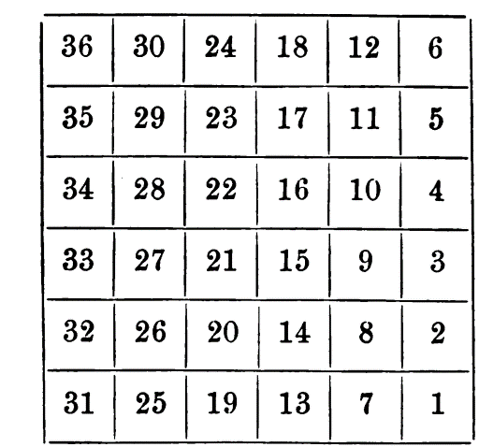

Station #5
Your job at this station is to make sure your first summary (NBE #19) contains the following information ***If it doesn’t, please add any missing information to the column next to your summary
- Northwest Ordinance of 1787
- Purpose: Determine when a territory could become a state
- Divided the Northwest Territory into 5 smaller territories (today, they are Michigan, Wisconsin, Illinois, Indiana, Ohio) *also included part of what today is Minnesota
- Each territory led by a governor
- As soon as a territory had 5000 FREE ADULT MALES, it could elect a lawmaking body (legislature)
- When a territory’s population hit 60,000, it could apply for statehood
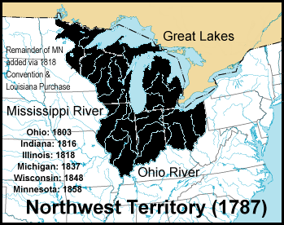

Station #6
- Open your notebook to NBE #20
- Read the opening paragraph on p. 105 of textbook
- Complete question #1 of NBE #20

Station #7
- Open your notebook to NBE #20
- Read the section entitled “Massachusetts Farmers Rebel” on p. 105 of the textbook
- Complete questions # 2-6 on NBE #20

Station #8
- Open your notebook to NBE #20
- Read the section entitled “A Call for Convention” on p. 105 of the textbook
- Complete questions #7-8 on NBE #20

