Map from Page 288 (shows free/slave states as of 1820)
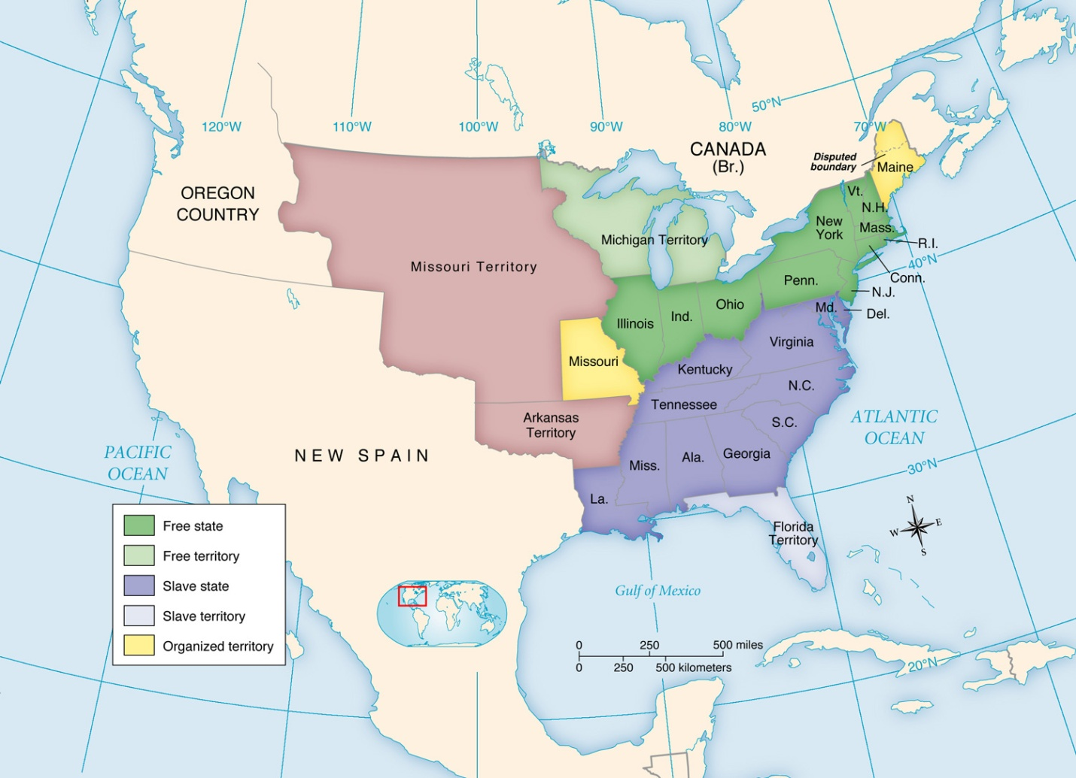

Map from Page 297 (shows free/slave states as of 1857)
